**Ulster University, Faculty of Computing and Engineering**

COM 409 - Client Server Application Development

Coursework - Semester 1 (10%)

Dr. Giuseppe Trombino

Due by – Friday 11th December 2015.

**Part 1: Project Proposal Plan and Design**

**Contents:**

* Group membership and project idea Page: 2
* Project aims and objectives Page: 3
* Requirements specifications Page: 4
* System design Page: 8
* Testing and evaluation Page: 14
* Workload distribution Page: 15

**COM409 Group 3:**

* *Ryan Kinley B00689149*
* *Gary McShane B00656764*
* *Jonathan P. McCrink B00656761*
* *Hugh Gerard McAleavey B00689147*

**Introduction:**

For this project we had a lot of work to complete before we could even look at designing the website and in this project we will cover these areas. The very first step of the project which had to be completed before any planning or design issues could take place was to decide what type of business we would setup and create a website and dynamic database for. We have chosen to build a website for “N4 Rentals” which is an expansion of a business which currently has a rental shop in Belfast. The owner wants to set up a DVD/Blu-Ray/Game Rental website, to allow customers to book and collect their desired item. Rentals are for a maximum of 7 days, and the entrepreneur wants customer to be able to see a history of their rentals. He also wants to be able to add/edit/remove details of the stock but has minimal knowledge of how to use a computer.

For this to be a success, we had to make sure we were receiving all the information from the entrepreneur regarding the products that he would like to rent to customers. We also had to allow the owner to have their own input on how they would like the system to be designed and which key features we need to implement.

**Group Membership:**

Group 3 is an elaborate and hardworking team which has decided to help out a local entrepreneur who currently owns a DVD/Blu-Ray/Game Rental shop in Belfast called “N4 Rentals”. He wants to set up a DVD/Blu-Ray/Game Rental website which will allow customers to order their desired product online and collect the item in-store. The team consists of Jonathan McCrink (Web Developer and Team Leader), Gary McShane (Web Developer), Gerard McAleavey (Web Developer) and Ryan Kinley (Web Developer). We have extensive knowledge working together due to being in teams in previous projects.

We have also decided as a team to that we are going to need to research the market before going ahead with the project as we want to ensure that the rental shop will be feasible and be a useful service which will be of benefit to paying customers that serves a purpose.

**Project Idea:**

Our Project idea has been thought up for a few weeks after a young entrepreneur who has very limited knowledge of how to operate a computer has challenged us to create a professional rental website. The website will allow customers to order the desired product of choice from the online catalogue for the customer to pick-up in store. With future enhancements we will possibly allow the customer to follow the transaction by paying online with a valid credit or debit card and then have the product delivered to the customer. Currently, there is only one store for the “N4 Rentals” shop in Northern Ireland and it is a small business so we are working for a small business that will not have large amounts of money to pump into a system that is only to enhance his current business.

Before a customer can order a disc, they will need to create an account with “N4 Rentals” so that a secure transaction can take place. We are going to need to receive an input for the username of the account, email address and password. Once an account has been created verification will be sent to the email address of the customer and a link which will then allow them to log into the site.

The idea of this project has come due to a potential gap in the market which sends out the discs to the customer extremely fast and at a cheaper rate than other competitors. Other competitors within the market are Xtra-Vison, Blockbuster and Netflix for example. Although Netflix doesn’t send physical copies to its customers it is still a competitor as it has a large customer base which it rents movies to.

We however feel that being able to have a physical copy of the disc for 7 days maximum rental time that it has a potential to be useful as the disc can be shared among close friends and family rather than having multiple Netflix accounts for example. Our business idea is also very intelligent as most customers don’t want to have to go to a rental shop and spend ages arguing over what DVD or game they want to borrow, instead they can spend time in the comfort of their own home and decide what they want to rent and then collect the disc in-store or pay for the shipping charge and have the disc delivered.

As a business idea we feel that there is a market for this type of service to the customer and will strive to produce a high quality website which customers will feel safe creating an account and potentially using credit cards on the web. When a customer accesses a web page the impact of the website has to provide comfortability, yet keep the customer’s attention span long enough to entice them to provide their personal details which they should feel safe with entering onto the web page. If this does not happen then the website will be of unimportant use and provide a poor level service to the customer and will be a waste of time, money and effort.

**Project aims and Project objectives (Details of what the system will achieve):**

One of the benefits of creating the system for the young entrepreneur is that we are going to require the user to create an account with the system before being able to process a transaction on the website. The customers will be enticed to create an account as the website will look appealing to draw in customers and furthermore have the entertainment products which they may be demanding to rent. By acquiring customer email addresses the entrepreneur will be able to then send out regular newsletters to his growing customer base and target the customers at specific peak season times when new releases are available or when there is a special offer / sale available.

On the back end of the website there will be a database which will allow the entrepreneur to be able to add, edit and remove any details of the current stock and make amendments as when required. The entrepreneur will not have to use the actual database, rather a GUI built into the back end of the website for ease of use. To access this section of the website you will have to use username and password authentication as an administrator to the site.

The system will achieve a website that will enable customers to view all the DVD’s, Blu-Ray’s and Game’s that are available for rental. Once a disc has been rented on the website the quantity of that disc will have to reduce on the database, until it is returned. This will be beneficial as he will have an understanding of how much stock is rented out and through the use of a computerised system will have access to the system compared to having a physical copy of the data in the store.

A project aim for the system will be to hold customer data such as login details which will consist of an email address and username. We will also need to hold data such as their contact details like phone number, address etc. for delivery/billing purposes. This will be the only data that the database will store about the customer. We will need to store the user’s password to the system also for log in purposes however this data will be encrypted in some way and will never be shown in plain text. This will ensure the security of all users’ accounts is not breached and that the system can remain safe with this aspect.

**Requirements Specification:**

The main requirement for N4 Rentals is of course a website. As we know the owner wants a website to list all his products such as DVDs, Blu-Rays and games for gaming consoles. The owner would like users to be able to view these products and book/rent for a maximum of 7 days through the site. Another requirement that the owner has is for the users/customers to be able to view a history listing of their rentals and from this an idea could be that they can book these products again quickly from this area.

The owner doesn’t have a lot of knowledge on how to use a computer, therefore adding products through the source code of the site wouldn’t be possible for him, therefore a solution is that there could be a secure area on the site for the owner, who would be an administrator of the site, to log in and add products through a form which will then be added to the site. This ensures a user friendly area for this novice user to be able to add/ edit and remove his products in the website.

Having thought of this, the website will then need two types of logins; one for customers/registered users and another for the administrator/owner of the site.

One major requirement that the site will need is a database. This will hold all data for all users plus products that will be handled throughout the site. Our logic is that all inserts, updates and deletes will be triggered within tasks carried out by users on the website. For example, as soon as a customer enters their details into a form at the registration stage and clicked a submit button, code behind this will INSERT all data from that form into a customer’s table in our database. See below a design of such table and then sample data that would be inserted into this:

**Customer**(ID,custFirstname,custLastname,DOB,email,tel,uname,pword,address,town,county,pcode,country)

Sample Data:

|  |  |  |  |  |  |  |  |  |  |  |  |  |
| --- | --- | --- | --- | --- | --- | --- | --- | --- | --- | --- | --- | --- |
| **ID** | **custFirstname** | **custLastname** | **DOB** | **email** | **tel** | **uname** | **pword** | **address** | **town** | **county** | **pcode** | **country** |
| 1 | Jonny | McCrink | 08.08.94 | [jmc@email.com](mailto:jmc@email.com) |  | Jmc01 | JmcC55 | 3 Grove St. | Newry | Down | BT35 7LJ | N.Ireland |
| 2 | Gerry | Smith | 24.10.81 | [smith@gmail.com](mailto:smith@gmail.com) |  | Gerry01 | gSMith3 | 65 High st | Belfast | Antrim | BT1 5JK | N.Ireland |

The same would go for a product table. The administrator is able to easily add products to the site by entering its details into a form. This data is entered into the database into a table called Product and just like the customer details, the product details are inserted to this table as soon as the admin user clicks a submit button on the add product form. See below a design of the Product database table and some sample data that would be inserted into this:

**Product**(ID,title,description,category,rentalPrice,rating)

Sample Data:

|  |  |  |  |  |  |
| --- | --- | --- | --- | --- | --- |
| **ID** | **title** | **description** | **category** | **rentalPrice** | **rating** |
| B1 | White House Down | Fast-paced action feature starring Channing Tatum, Jamie Foxx | Blu-Ray | £5.99 | 12 |
| D2 | The James Bond Collection | Collection of 23 films based on the James Bond character created by Ian Fleming | DVD | £18.99 | 15 |
| G3 | Fallout 4 | Return to the wasteland in Fallout 4 | Games | £12.99 | 18 |

As mentioned the main requirement is of course a website therefore the products of the rental company will be presented in a professional, appealing, user friendly website that will be enjoyable for all users to use. When a user initially visits the site, they will be presented with an exciting page that will draw them in. We want to make the site as easy to use as possible therefore ensuring that it won’t push users away and also will ensure that it is easy for the admin/owner to manage such as adding or maintaining products.

The user will first land on our home page where they will straight away find the fixed nav-bar at the familiar position at the top of the page. They will be able to use this to navigate through the site, visiting their desired category which will be DVD’s, Blu-Rays and/or Games. Visiting these pages will then allow the users to view all products available within that category and from here they will be able to book a product. All products will have sufficient details available to it such as titles, descriptions including actors etc. as well as an uploaded visual image of that product, its rating and of course its rental price. As soon as the user finds their desired product the, the process of booking will be very easy prompting users to just enter how long they intend to rent the product and simply click a book button.

When the customer clicks to book a product they will be directed to their order screen where they can then checkout or continue to browse, however this is only on the basis that the customer is logged into the site as a registered user. If they are not, then the site will re-direct them to the log in screen where the user can then log in. However if that particular user is not registered on the site then they can register via a form on this same page. They will be required to enter in their details into a form as mentioned above and clicking submit where they will then be logged in. At this stage they can then progress onto booking their product as a logged in registered user.

A tab on the nav-bar will drop down to a combo-box giving a user a choice to log in as an admin or a customer. Of course only authorised users will be able to log in as an admin and if a customer would try to log in with their own credentials, then their access will be denied. This brings in a security aspect of the site.

Once a user is logged into their respected account type of the site, they can carry out a number of different tasks. Take a customer user first. When they log in, they will be directed to a section called ‘My Account’. An important requirement from the owner is that customers can view their rental history, therefore when the customers are logged into ‘My Account’; they can view a listing of their whole rental history in a simple readable table and also from here if they wish, they can click a link to book a particular product again from the listing, which will re-direct them as a logged in user to that particular products page, where they can then rent that product again.

If the administrator is logged into the website, they will be directed to a section called ‘Admin Management’ where they can then perform tasks such as adding new products through a form, which you can see later in mock up screens, and also can view all products that are currently on the site and edit their details or indeed remove that product if required. Having the feature where content is added through a form interface is much more user friendly for novice users to computers rather than having to add the products through the source code of the site, which we would assume the owner would have no knowledge of doing so.

As mentioned earlier the registration area will have all passwords hashed to ensure protection of the contents of the field.  Industry standards for password encryption include SHA-2 and SHA-3 and either are valid option. As well as password encryption it's important to make sure the webpage itself is secure.

To ensure this the website will have a self-signed SSL certificate and will feature HTTPS protocol capabilities. These measures of protection ensure that HTTPS packets sent to the website over an insecure local network, (eg. airport Wi-Fi) cannot be packet sniffed. With public and freely accessible Wi-Fi hotspots becoming more widely available than ever before. These measures help to mitigate the danger to the company's customers from hackers. Another important measure which will be enforced is a password policy. The password policy will ensure all users have a minimum level of entropy were a hacker to attempt to brute-force crack their user account.

This password policy will require a password to have at least one capital letter, be at least nine characters long and feature at least two numbers.  When a login fails six times consistently the user account is locked and an email is sent to the account holders email address informing them of the failed attempts and asking them to follow a link to reset their password. In the case of an administrator account the number of failed account logins is lowered to three.

Registering on the site will require the user to agree to the terms and conditions of the website making the company legal stance on fraud and stealing from the system clear, this an important aspect of the general requirements. Without the website may have little legal validation in the possibility of a court summons.

Once the T&C's have been accepted and user data has been entered into the registration area. The registrant receives an email informing them of their successful registration. From this point on a member can login from the User login screen. When the user logs in they are brought to a “secure area" this area is made secure in the same fashion as the User Registration page, the webpage is displayed in the HTTPS protocol with the self-signed cert still on display.

Within this area the user is able to view all their account details including rental history, a "wish list" feature which will enable customers to compile a series of movies or television shows they would like to rent but simply don't have the time to watch right now. From this main hub a user can edit any account information, home address, password or email address etc.

In order to remain competitive with other major online movie and game rental companies such as Xtra-vision, we will be implementing more user friendly content by offering increased customised content within the Member hub. This will include being able to change the background colour of the webpage once a user has logged in as well as accessibility options including font enlargement options which will change all font on the website to display larger and more clearly for user's that may have difficulty viewing the webpage in its standard format. Users will be able to upload add a profile picture to their account area.

All movies, games and television shows that a user rents can be reviewed after rental. The user dashboard will feature several widgets displaying interesting site data for the user including ones listing "Most Popular Rentals this Month", "Most Popular Rentals of All Time",  "Highest Rated Movies" as well as a "Staff Favourites this Month". Often a user may find that they want to watch a movie or play a game but simply don't know any "good" ones. These displays of suggestions offer the user the opportunity to try something unknown and if they find the movie.

The user is able to submit both a written review and a rating review out of five. All this content will then be available from the display page for that item. As an added incentive for users to sign-up to the site these reviews will be unavailable to view until a user has logged in. An invitational system built to encourage established users to invite new ones will also be available.

A user will be able to share a unique link to a friend taking them to a registration page. Once the friend registers as a new user and carries out their first rental the original user will receive a 20% discount on their next rental.

One last requirement for the site is that there will be custom content for each user logged in. we have touched on this briefly but basically what this will be is when a user logs into their account, they will be presented with a table listing their rental history from previous purchases from the site. Each user’s content will be custom to that particular user because of the fact that they have rented different products. This content will be secured and can only be accessed to that particular user as it will be within the secured account and can only be accessed using their login username and password.

The N4 Rentals site/system will be created by the team taking all these requirements into consideration and making sure that each of these are implemented into the site. These are the key requirements for the user therefore we want to ensure that these are all met with the best interest of the owner of N4 Rentals! Later in this document you will see the structure of the site in terms of DFDs and also several mock screens which can show a real aspect of how the site is going to look. From these you will also see that some of the requirements are taken into consideration including the aspect of the custom content for all users by listing the user’s rental history in the users account.

Customer selects desired category

Start: Customer visits website

**System Design – Data Flow Diagram:**

DFD showing the flow of a customer using the site.

Customer browses products from category

**System Design: Entity Relationship Diagrams:**

Customer Logs out

Customer checkout order

Confirmation email of order

Alternatively customer finish

End: Customer leaves website

Customer selects next desired product

Customer clicks book product

Yes

Customer registers on Sign-up page

Customer Logs in

No

Is customer already logged in?

Yes

Confirmation email of customer signup

No

Is customer a registered user?

Customer selects desired product

*Step 1 - Listing the key entities identified (together with main attributes):*

**Product**(ID,title,description,category,rentalPrice,rating)

**Customer**(ID,custFirstname,custLastname,DOB,email,tel,uname,pword,address,town,county,pcode,country)

**Rental** (rentalProductName, rentalnumberOfDays, rentalPrice, custFirstName, custSurname, contactNo, custAddress, custTown, custPostcode)

*Step 2 - Describe relationship between entities:*

*Customer – product M: N*

*A customer can rent one or more product*

*A product is rented by one or more customer*

*Customer – rentalNote 1: N*

*A customer receives a rental note*

*A rental note is given to one or more customer*

*Step 3 – ER Diagrams:*

Rents

Receives

Rented by

Product

Customer

Sent to

Rental Note

*Resolve M: N Relationship:*

Refers to

Customer

CustomerProduct

Rental Note

Product

Rents

Refers to

Sent to

Rented by

Refers to

Receives

*Optional Relationship:*

Refers to

CustomerProduct

Refers to

Sent to

Customer

Rented by

Receives

Product

Rental Note

**System Design - Data Dictionary:**

See below a listing of all tables that will be in our database. Included here is each attribute needed as well as its data type. A screen shot with sample data is also provided.

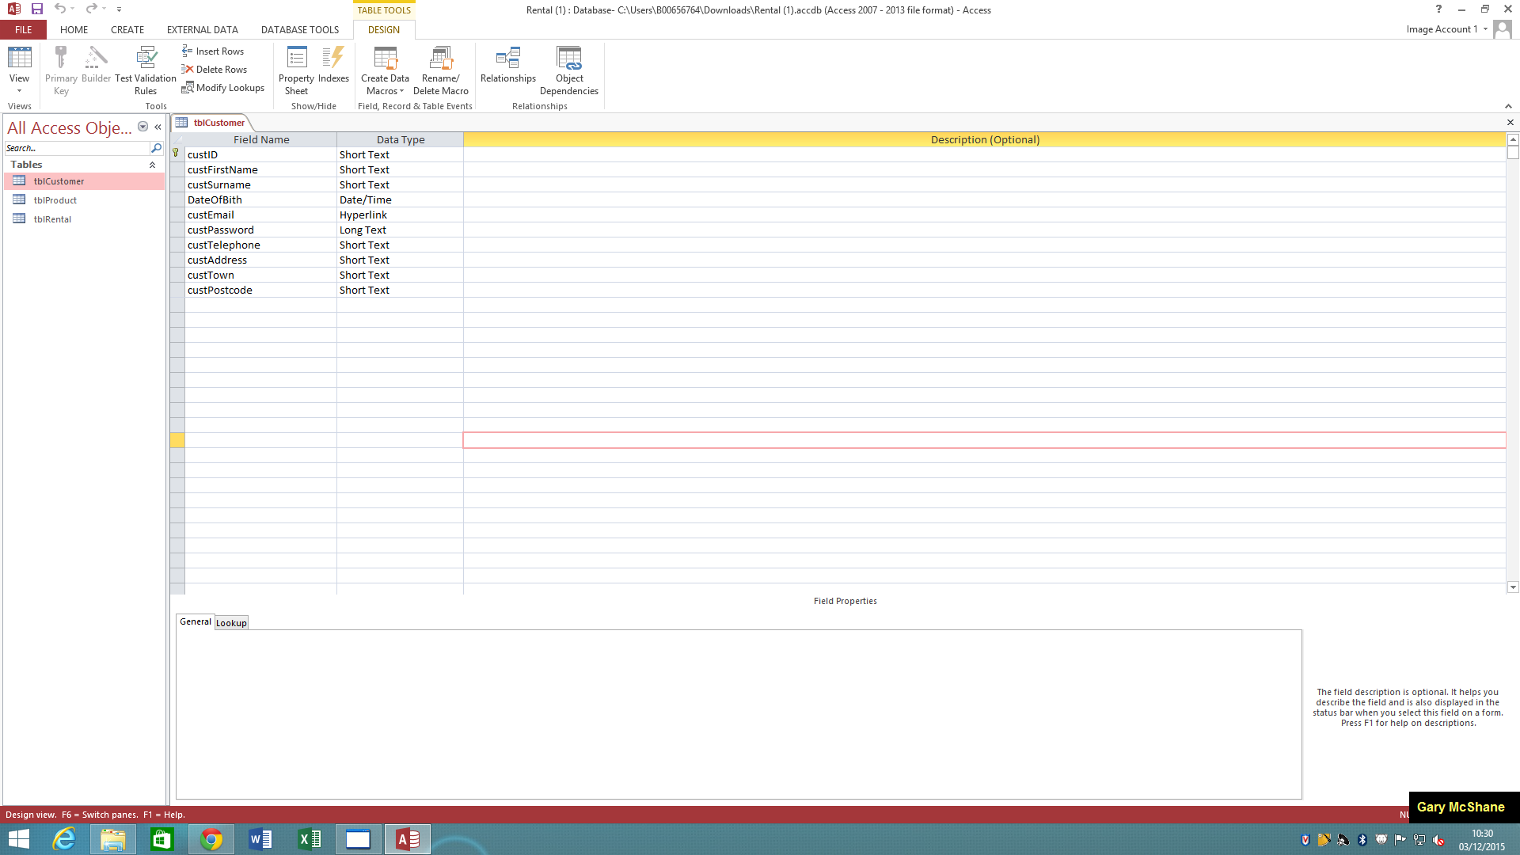***tblCustomer***

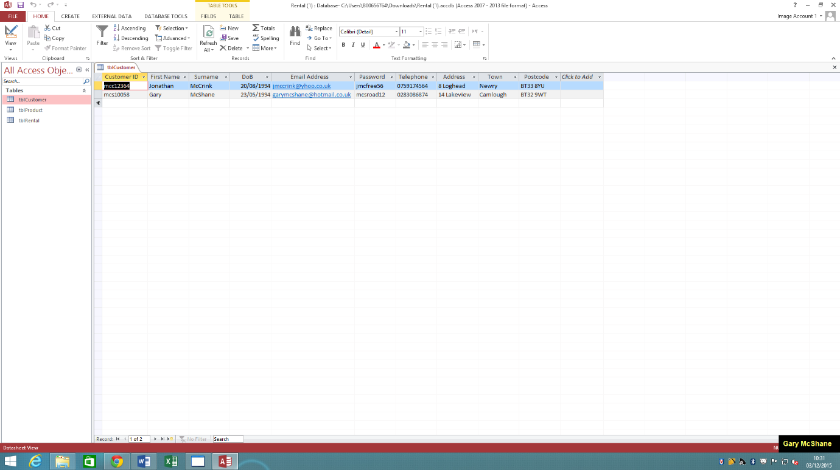

***tblProduct***

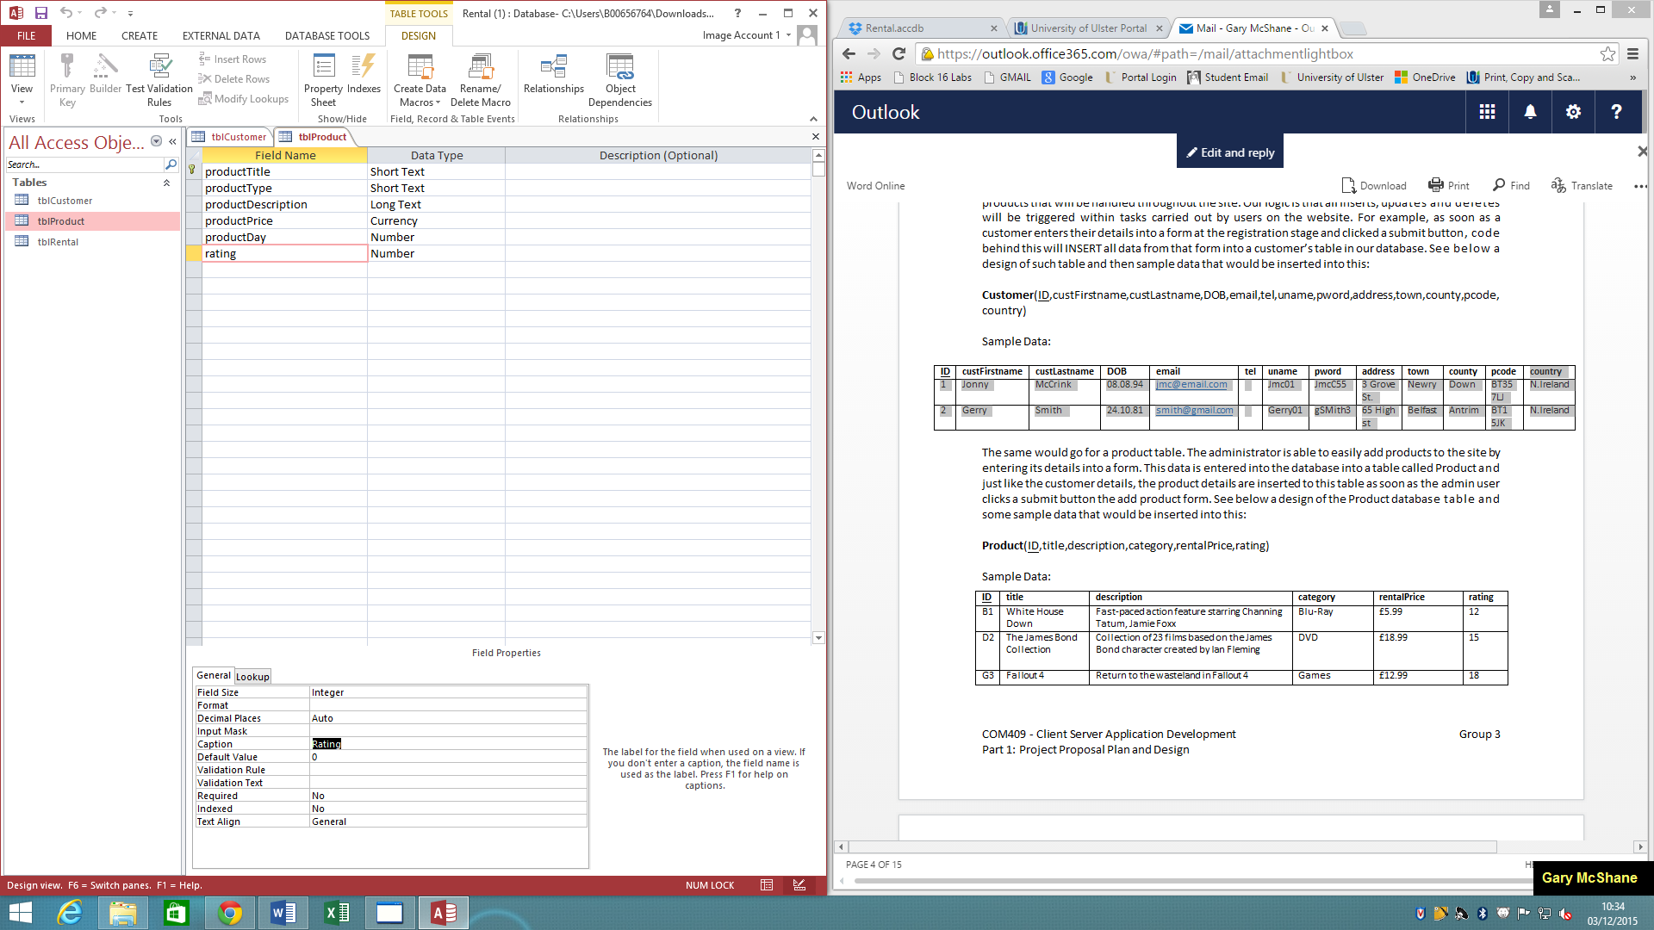

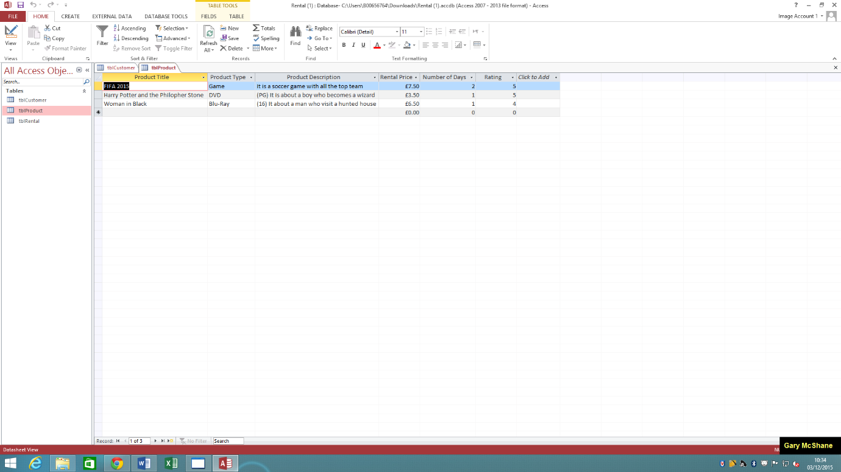

**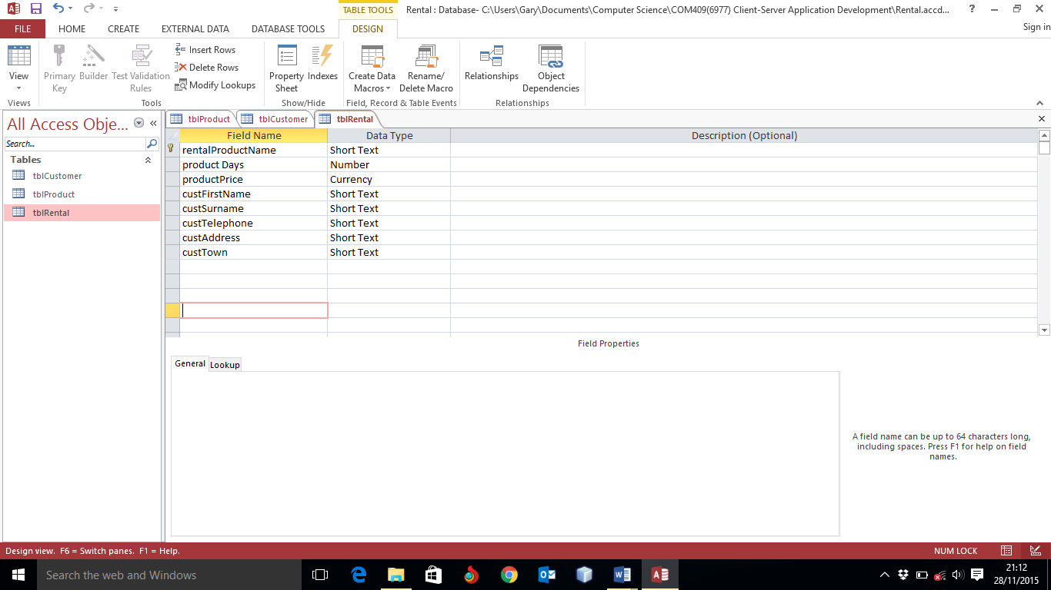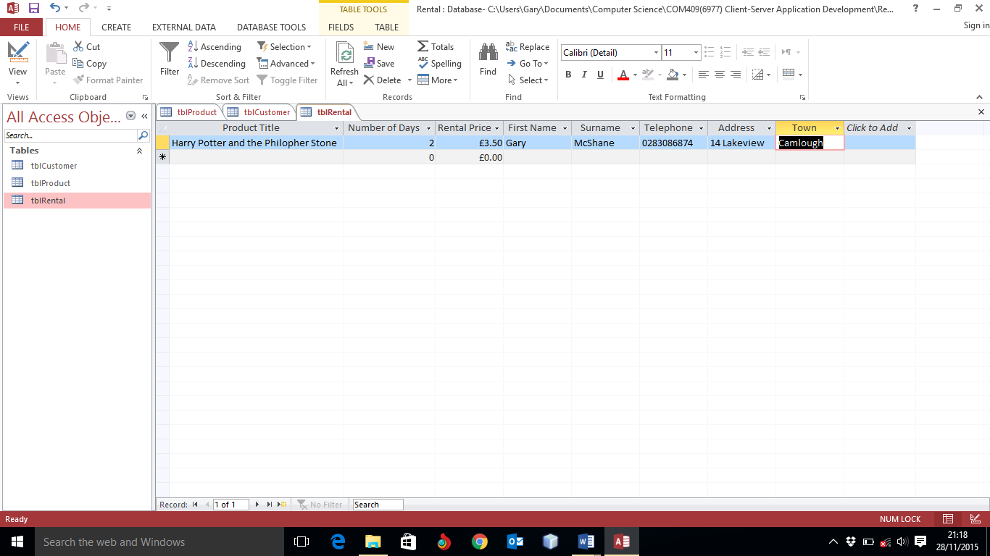*tblRental***

***System Design – Website Mock Screens:***

Users will first see this page when they visit the website. The site has a clean user appealing deign with nav-bar along the top along with website name/logo. This is consistent throughout the website.

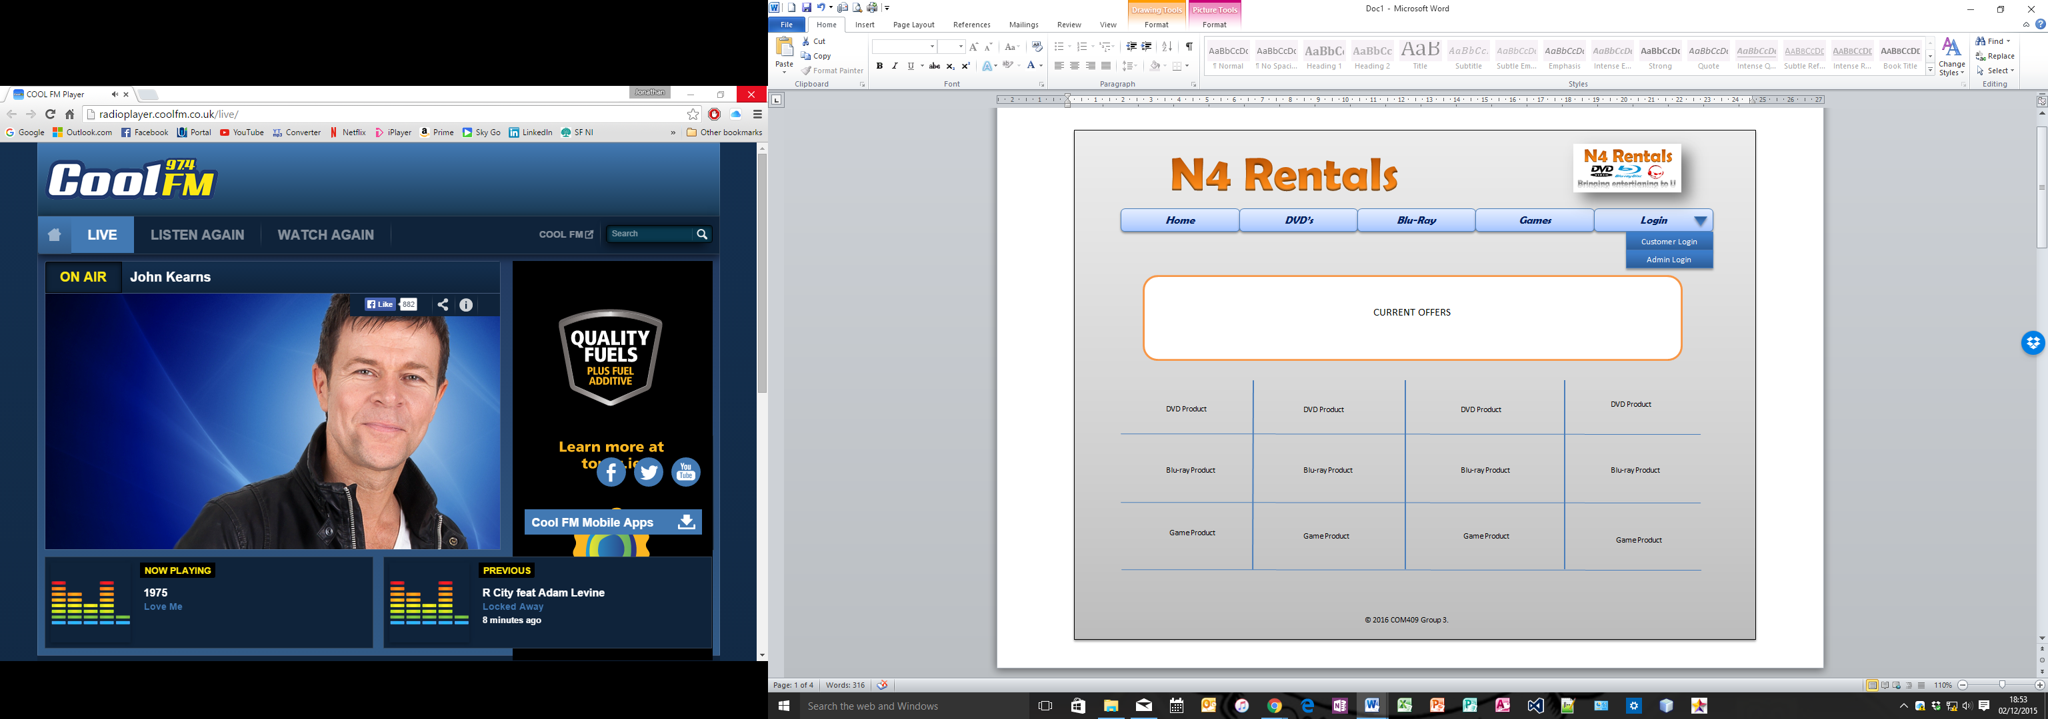

The main home page will first show a container showing special offers for that current time. This is placed at the top of the page so users will be drawn to this.

As users scroll down the page they will see a short listing of a few products for each of the three categories. To see all products they will need to click into their desired category in the nav-bar.

The login link will open a dropdown and give the user an option to login as a customer or an admin. Admin will use their login to complete tasks such as adding/editing or removing products from the site. A mock screen of adding a product can be seen below.

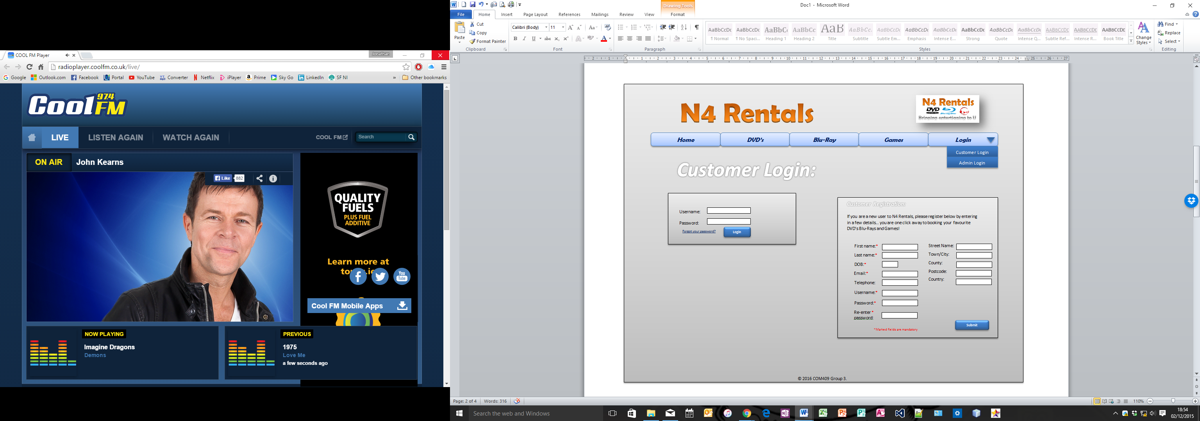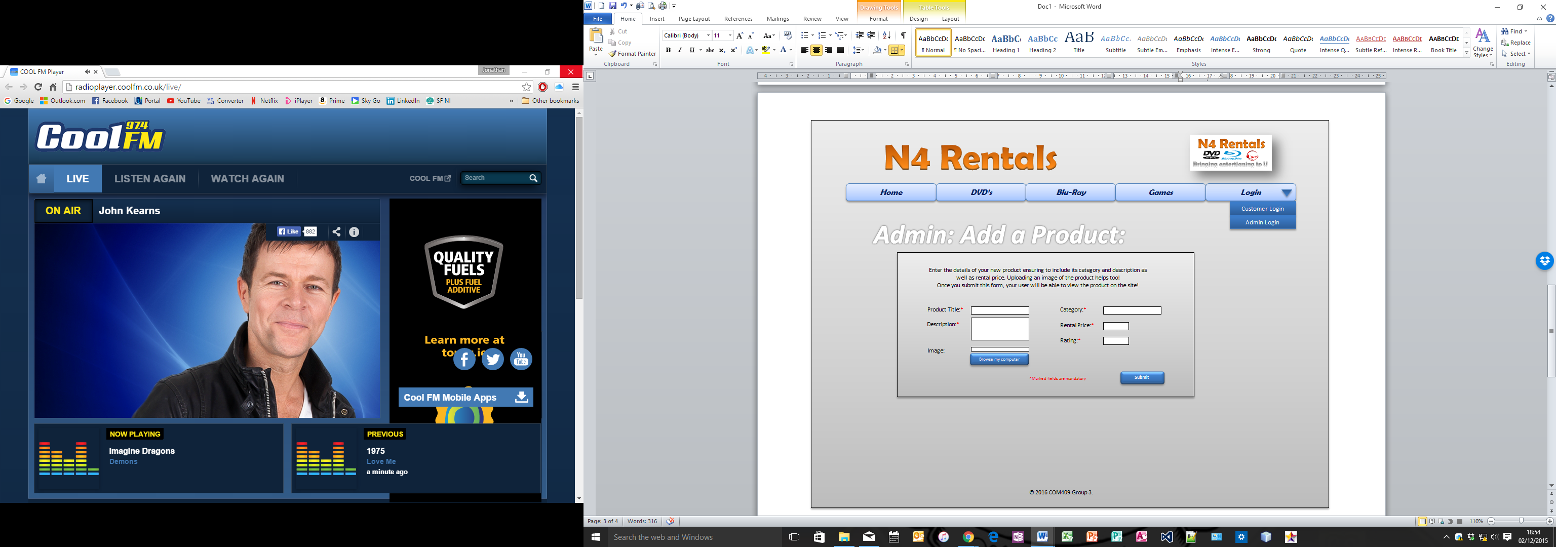

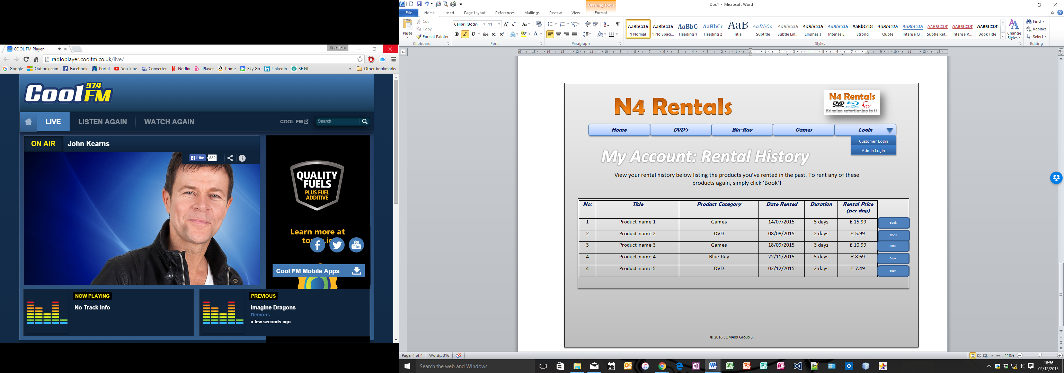***System Design – Hierarchy:***

If the user clicks Customer login, they will be brought to this page as seen above. They can then log in with their username and password. If however they are not already registered, they can do so by filling in the form on the right. Validation will be included here to ensure all mandatory fields are entered. Clicking ‘Submit’ will then trigger an INSERT to the database with the customer details.

Above we can see a simple page that is only available to Admin users. They can add a new product using the form which will then INSERT the details to the database. Other pages will be created to edit/remove products.

To the left we see a page that is within the Customer login. They can view their rental history here from a table which performs a SELECT from the database. Customers can quickly book a product again by clicking ‘Book’ which will redirect them to that products booking page using its unique ID.

Home

Login

Blu-Rays

Games

DVD’s

Administrator Login

Customer Login/Register

DVD Product

Blu-Ray Product

Games Product

Add new product

Edit/remove product

View order history

Product checkout

Confirmation page

Administrator Logout

Customer Logout

***Testing and Evaluation Plan:***

When it comes to Testing the website to ensure that it is fit for purpose we will be using either White-box or Black-box. The Black-box testing involves testing the user’s interaction with the product without knowing the code behind it. This ensures that the product is working as expected. Even though the code has changed the product will be successful at the testing as long as the functionality of the interface hasn’t been altered. Black-box testing is best suited with there is large segments of code as well as with the user does not need access to the code itself. Whereas the White-box testing examines the code of the product meaning the tester is required to know the code behind the interface. For instance, if there is a validation conditions, as part of the test the tester may wish to repeat those validation conditions. With White-box testing it is essential that the test are prior knowledge of the product and the code that is running it. This type of testing help detect errors and problems within the code as well as ensures that the tester has prior knowledge of the code the purpose of it.

After considering the two types of testing (White-box and Black-box), the testing method best suited to this product is the Black-box testing. The reason for this, is for the fact that the testing will involve the outcome of the user’s actions, for example what will happen when the user clicks on the Login tab, or what will happen the user clicks on the DVD, Game or Blu-Ray images e.g. will it take them to the appropriate pages on the website or will a different action occur instead. Also the test will look at what will happen when the user wants to rent the product from the website. In order to carry out this activity a member of the group will test the website as an external user. Here is an example of the test plan:

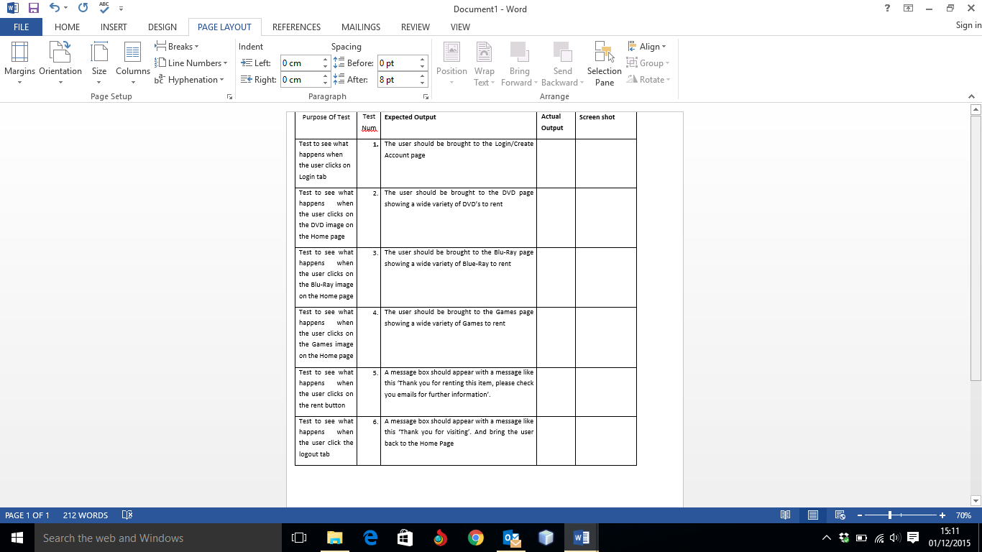

***Workload Distribution:***

The workload distribution is an important stage for the development of this website for the N4 Rentals. As we are a group we need to distribute the workload of implementation of the site/database evenly between the 4 members of the group.

As I, Jonathan McCrink, have been elected as the group leader, the group together made the decision that it would be my job to distribute the workload out to the remaining remembers of the group which I am happy enough to perform.

Having looked at all the member’s strengths and weaknesses, I have placed them in positions to ensure that they are working on aspects of the task that they can perform to their best abilities. In other words, I have made sure to give them tasks to suit their strengths.

Within this proposal plan document, Gary McShane has designed the main database including table designs, data dictionary etc. therefore it would make total sense that he implemented our database for the site. I have full confidence that Gary can perform this very well.

I myself have had quite a substantial amount of experience in HTML/HTML5 and CSS therefore I will be taking on the majority of implementing pages for the site and styling using CSS, however this will involve the whole team at times for creating content etc. I also will be taking care of deadlines and management for the task. I will set a timeline for the whole task and ensure that we have checkpoints and have certain aspects of the task completed on these timelines. This will ensure that the team can work effectively and efficiently and will mean that we can meet deadlines and will ensure that come the end, we are meeting the submission deadline for the client.

The whole team have had the same amount of experience in PHP development therefore we will be each having our own sub tasks for the coding in PHP and helping each other throughout. After quite a bit of thinking and discussing about this, I feel this is the best suited way to distribute this aspect of the task because I don’t feel it would be very fair to allow one individual member to implement all PHP for the site because of the fact that we all have only little experience of this. It will be a new learning curve for us all and together I feel we can complete this aspect together.

I feel Ryan Kinley and Gerard McAleavey will be comfortable testing the site throughout implementation and commenting back to the team where flaws are and where we will need to improve or act upon. This is a very important task for the site because without this we could potentially release a site that doesn’t work in certain or even majority of areas therefore this needs to be carried out throughout the implementation stage and definitely at the end. I feel these two members are very capable of this and reporting back to the team of their findings.

Again the whole implementation of this site will be a team effort, with certain tasks distributed fairly and equally throughout the team. We will of course be all coding HTML, CSS and PHP however some team members will be doing more in one language than others as mentioned.

I feel as a team and with this workload distributed in this plan, we can create a very good website with supported database, we can meet deadlines and most importantly meet the requirements of the rental store owner and ensure that he and his customers will be happy using their N4 Rentals site!